**КИЇВСЬКИЙ ФАХОВИЙ КОЛЕДЖ ЗВ’ЯЗКУ**

**WORK-CASE №6**

з дисципліни «Операційні системи»

Виконали: студенти **3** курсу, групи **КСМ-13А**

**Засенко Олександр**

(прізвище та ініціали)

**Дзюбенко Дмитро**

(прізвище та ініціали)

**Сторожук Костянтин**

(прізвище та ініціали)

Київ  2023

**ЗМІСТ**

How to install other command prompts in the Linux ………………………………...……..3

How to create 10 new users in your system ……………………………………..………….4

How to define default command prompt …………………………………...………………6

Demonstrating examples …………………………………………………..….……………7

Conclusions…………………………………………………………………………………8

**The material was prepared by a student Zasenko**

1. To install other command prompts in the Linux operating system, you can use the package manager that is responsible for your distribution. Here are two other command prompts, how to install them, and brief descriptions:
2. zsh (Zsh):

* Installed in Ubuntu or Debian: sudo apt-get install zsh
* Installed in Fedora: sudo dnf install zsh
* Installed in Arch Linux: sudo pacman -S zsh

Zsh is a powerful and extensible command prompt that provides many additional features, such as auto-completion, command history, plug-in support, and theme support. It supports various shell configurations and customizations and is popular among advanced users.

1. fish (Friendly Interactive Shell):

* Installed in Ubuntu or Debian: sudo apt-get install fish
* Installed in Fedora: sudo dnf install fish
* Installed in Arch Linux: sudo pacman -S fish

Fish is a friendly and interactive command shell. It has a simple and intuitive command syntax and auto-completion that makes it easy to use. Fish supports command history, color highlighting, and other convenient features. It is aimed at facilitating user interaction with the system and provides a friendly and intuitive interface.

Installation usually requires administrator (sudo) privileges. After installation, you can switch between different command prompts by using the chsh command and selecting the desired prompt.

**The material was prepared by a student Dziubenko**

2. You need to create 10 new users in your system and assign them to groups:

* Technical support (technical support, system administrators);
* Developers (developers, technical specialists in their field);
* Financiers (accounting, economists, etc.);
* Founders (management);
* Guests.

To create 10 new users and assign them to groups, you need to run several commands:

1. Create groups:

sudo groupadd technical_support

sudo groupadd developers

sudo groupadd financiers

sudo groupadd founders

sudo groupadd guests

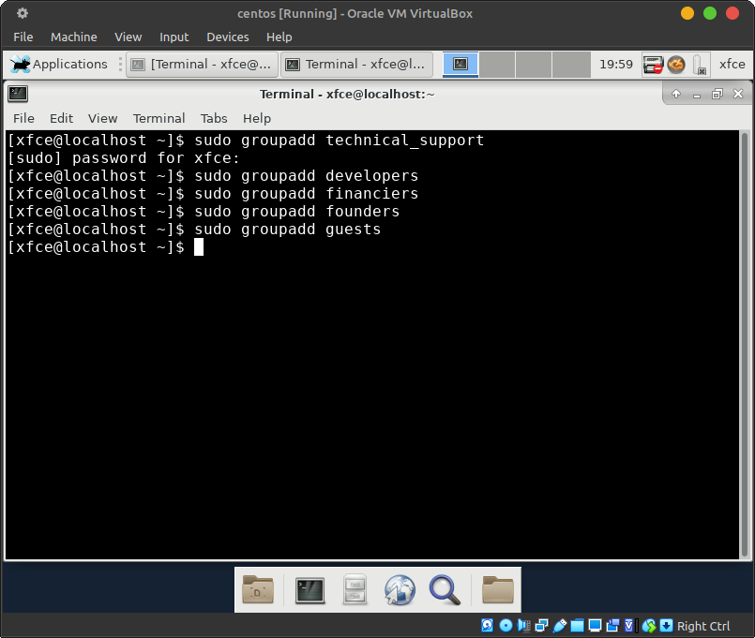

Fig 1. Creating groups

2. Create users and assign them to the appropriate groups:

sudo useradd -m -p 1q2w3e -g technical_support -s /bin/bash user

sudo useradd -m -p 1q2w3e -g developers -s /bin/bash user

sudo useradd -m -p 1q2w3e -g financiers -s /bin/bash user

sudo useradd -m -p 1q2w3e -g founders -s /bin/bash user

sudo useradd -m -p 1q2w3e -g guests -s /bin/bash user

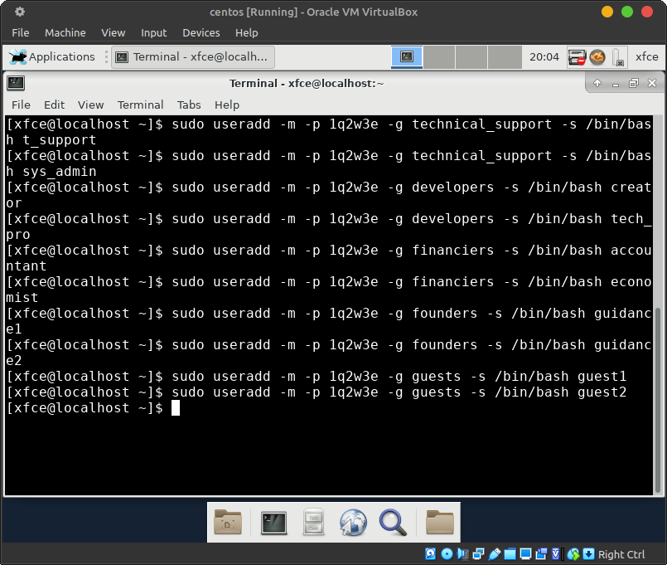

Fig 2. Creating users

3. For each user, define its default command prompt:

* Technical support - bash;
* Developers - command prompt 1 (task 1);
* Financiers - deny access to command prompts;
* Founders - command prompt 2 (task 1);
* Guests - deny access to command prompts.

To define a default command prompt for each user group and deny access to command prompts for certain groups, you need to make changes to the /etc/passwd file:

sudo nano /etc/passwd

Find the line for each user you created earlier and make changes to the command prompt field:

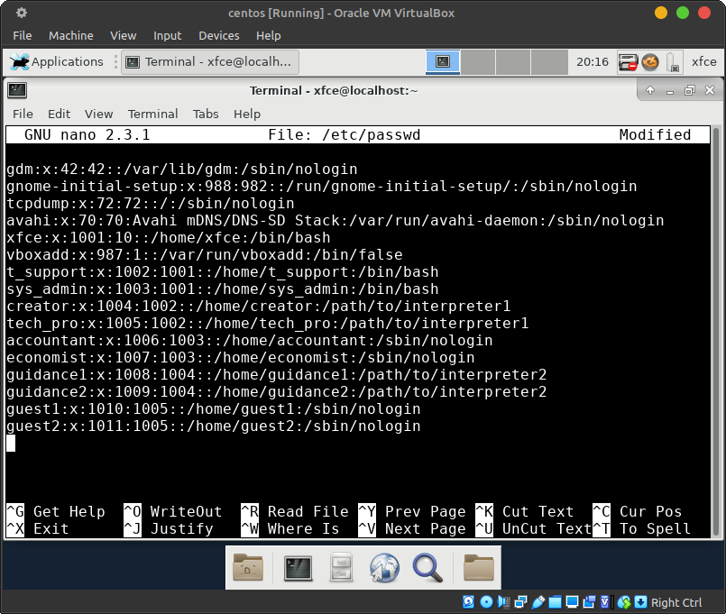

Fig 3. Make changes to the command prompt

After making changes to the /etc/passwd file, save it and exit the text editor.

4. Demonstrate examples of how each user group works in its own command prompt - for example, collecting information about the system, determining the basic configuration, system date, current directories, etc.

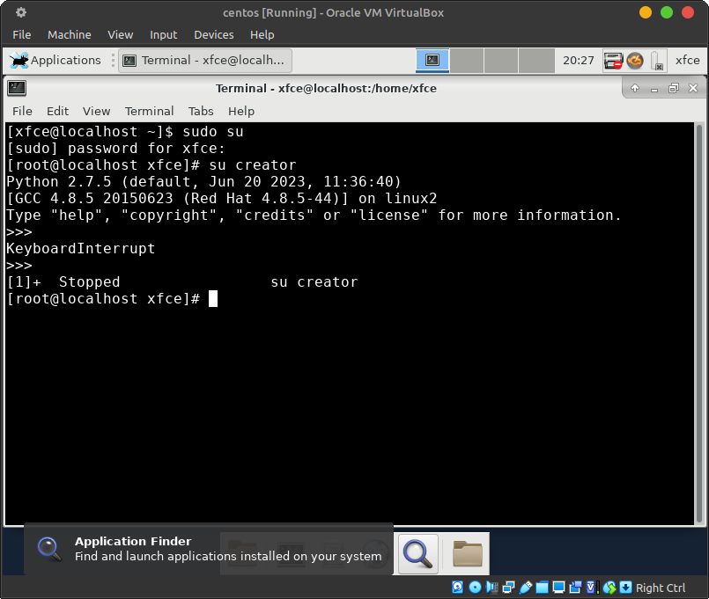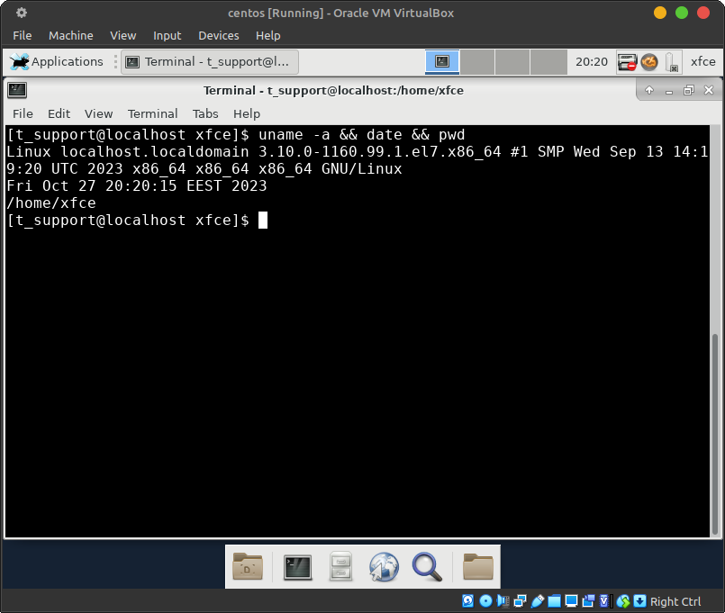

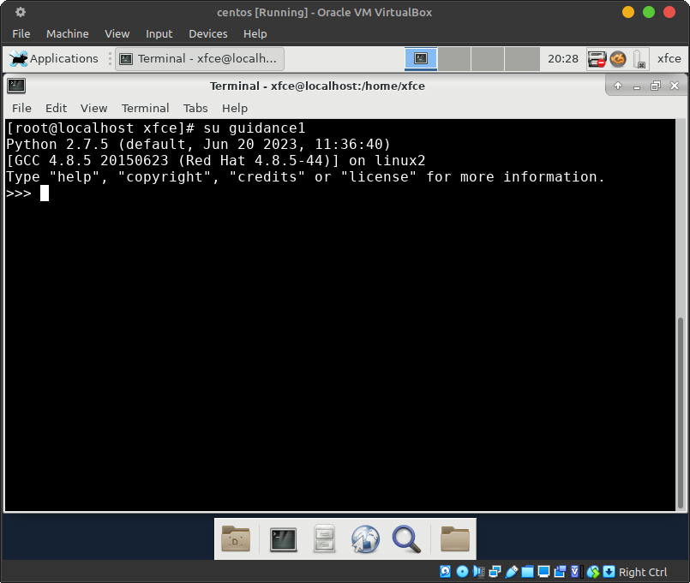Fig 4. Each user group works in its own command prompt

**Conclusions**

***The material was prepared by a student Storozhuk***

In this paper, we installed several command prompts in the operating system workspace and learned how to do it in practice, and we added new users to our system and defined a command prompt for each user. We did not encounter any problems.